**AIM: To create a full duplex communication system using tcp ip**

Server Code:

#include<sys/types.h>

#include<sys/socket.h>

#include<stdio.h>

#include<unistd.h>

#include<netdb.h>

#include<arpa/inet.h>

#include<netinet/in.h>

#include<string.h>

int main(int argc,char *argv[])

{

int clientSocketDescriptor,socketDescriptor;

struct sockaddr_in serverAddress,clientAddress;

socklen_t clientLength;

char recvBuffer[1000],sendBuffer[1000];

pid_t cpid;

bzero(&serverAddress,sizeof(serverAddress));

/*Socket address structure*/

serverAddress.sin_family=AF_INET;

serverAddress.sin_addr.s_addr=htonl(INADDR_ANY);

serverAddress.sin_port=htons(9037);

/*TCP socket is created, an Internet socket address structure is filled with

wildcard address & server’s well known port*/

socketDescriptor=socket(AF_INET,SOCK_STREAM,0);

/*Bind function assigns a local protocol address to the socket*/

bind(socketDescriptor,(struct sockaddr*)&serverAddress,sizeof(serverAddress));

/*Listen function specifies the maximum number of connections that kernel should queue

for this socket*/

listen(socketDescriptor,5);

printf("%s\n","Server is running ...");

/*The server to return the next completed connection from the front of the

completed connection Queue calls it*/

clientSocketDescriptor=accept(socketDescriptor,(struct sockaddr*)&clientAddress,&clientLength);

/*Fork system call is used to create a new process*/

cpid=fork();

if(cpid==0)

{

while(1)

{

bzero(&recvBuffer,sizeof(recvBuffer));

/*Receiving the request from client*/

recv(clientSocketDescriptor,recvBuffer,sizeof(recvBuffer),0);

printf("\nCLIENT : %s\n",recvBuffer);

}

}

else

{

while(1)

{

bzero(&sendBuffer,sizeof(sendBuffer));

printf("\nType a message here ... ");

/*Read the message from client*/

fgets(sendBuffer,10000,stdin);

/*Sends the message to client*/

send(clientSocketDescriptor,sendBuffer,strlen(sendBuffer)+1,0);

printf("\nMessage sent !\n");

}

}

return 0; }

**Client Code:**

#include "stdio.h"

#include "stdlib.h"

#include "string.h"

//headers for socket and related functions

#include <sys/types.h>

#include <sys/socket.h>

//for including structures which will store information needed

#include <netinet/in.h>

#include <unistd.h>

//for gethostbyname

#include "netdb.h"

#include "arpa/inet.h"

int main()

{

int socketDescriptor;

struct sockaddr_in serverAddress;

char sendBuffer[1000],recvBuffer[1000];

pid_t cpid;

bzero(&serverAddress,sizeof(serverAddress));

serverAddress.sin_family=AF_INET;

serverAddress.sin_addr.s_addr=inet_addr("127.0.0.1");

serverAddress.sin_port=htons(9037);

/*Creating a socket, assigning IP address and port number for that socket*/

socketDescriptor=socket(AF_INET,SOCK_STREAM,0);

/*Connect establishes connection with the server using server IP address*/

connect(socketDescriptor,(struct sockaddr*)&serverAddress,sizeof(serverAddress));

/*Fork is used to create a new process*/

cpid=fork();

if(cpid==0)

{

while(1)

{

bzero(&sendBuffer,sizeof(sendBuffer));

printf("\nType a message here ... ");

/*This function is used to read from server*/

fgets(sendBuffer,10000,stdin);

/*Send the message to server*/

send(socketDescriptor,sendBuffer,strlen(sendBuffer)+1,0);

printf("\nMessage sent !\n");

}

}

else

{

while(1)

{

bzero(&recvBuffer,sizeof(recvBuffer));

/*Receive the message from server*/

recv(socketDescriptor,recvBuffer,sizeof(recvBuffer),0);

printf("\nSERVER : %s\n",recvBuffer);

}

}

return 0;

}

**Output:**

**Client :**

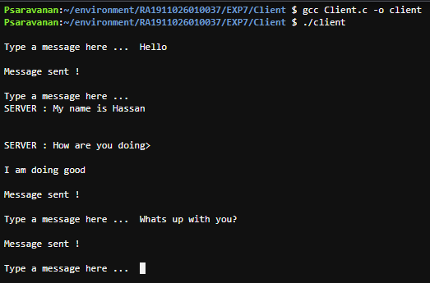

**Server:** 